AMERICAN COMPUTER SCIENCE LEAGUE
2001 - 2002

All-Star

SOLUTIONS

1. RECURSIVE FUNCTIONS

f (9, 4) = f (7, 9) = -15 (A)
f (7, 9) = f (5, 19) = -15
f (5, 19) = f (2, 18) +2 = -15
f (2, 18) = f (-1, 17) +2 = -17
f (-1, 17) = -19

2. COMPUTER NUMBER SYSTEMS

9C6₁₆ = 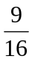 + 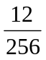 + 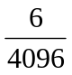 = 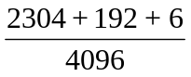 = 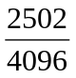 = 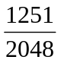 (D)

3. BIT STRING FLICKING

(RCIRC-3 (LSHIFT– 1 (01011 AND abcde))) (RSHIFT–2 (LCIRC–1 (10111 OR abcde ) ))

01011 10111
AND abcde OR abcde
0bode 1b111

LS-1 b0de0 LC-1 b1111
RC-3 de0b0 RS-2 00b11

de0b0
XOR 00b11
debB1

d = 1, e = 0, b = 1, a = *, c = * therefore the solution is * 1 * 1 0. (E)

4. DATA STRUCTURES

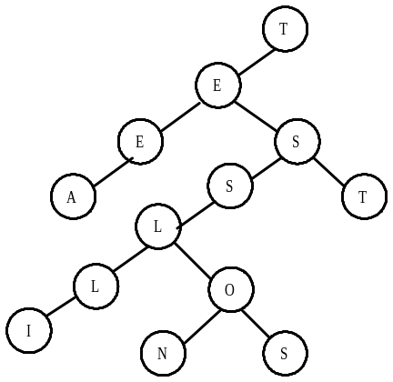The tree is constructed as below and has an external path length of 72. (A)

5. GRAPH THEORY

The adjacency matrix is formed and then cubed. (C)

Adjacency Matrix Matrix cubed
 | A | B | C | D | E | F
A | 0 | 1 | 1 | 1 | 0 | 0 |  | 2 | 2 | 2 | 2 | 1 | 1
B | 1 | 0 | 0 | 0 | 0 | 1 |  | 3 | 0 | 1 | 0 | 1 | 2
C | 1 | 0 | 0 | 0 | 0 | 0 |  | 2 | 0 | 1 | 0 | 1 | 1
D | 0 | 0 | 1 | 0 | 1 | 0 |  | 0 | 2 | 2 | 2 | 1 | 0
E | 1 | 0 | 0 | 0 | 0 | 1 |  | 3 | 0 | 1 | 0 | 1 | 2
F | 0 | 0 | 0 | 0 | 1 | 0 |  | 0 | 1 | 1 | 1 | 1 | 0

6. DIGITAL ELECTRONICS

The circuit translates to: (A + B) (NOT B + C) ⊕ A . Using the identity X ⊕ Y = X∗NOT Y + NOT X ∗Y, the expression simplifies to A∗B ∗NOT C + NOT A∗B∗C = B(A∗NOT C + NOT A∗C) = B(A⊕C). (D)

7. BOOLEAN ALGEBRA

(A + B ) ( BC ) is the translation of the circuit

The expression simplifies to (A ∗NOT B) (B ∗ NOT C) = A * 0 * NOT C = 0. This implies that the expression is always false. All 8 combinations make the expression false. (D)

8. EXPRESSION TRANSLATION

The expression translates as follows: 1 + 1 / ( 1 + 1 / ( 1 + 1 / x ) ). There are 2 sets of parentheses required. (C)

9. LISP

Starting with the inner most parentheses the expression evaluates as follows:

REVERSE (( 1 3 ) 8 (( 5 6 ) 7 ) ( 1 ( 2 3 ) 4 ))
CDR ( 8 (( 5 6 ) 7 ) ( 1 ( 2 3 ) 4 ))
REVERSE (( 1 ( 2 3 ) 4 ) (( 5 6 ) 7 ) 8)
CDR (((5 6) 7 ) 8)
CAR ((5 6 ) 7 ) (E)

10. PREFIX/INFIX/POSTFIX

Translating to infix produces: ( ( 12 ! 18 ) * (2 # 3 ) / ( 6 ! 8 ) ↑ 2) ↑ ( 9 ! 15 ) =
( 6 * 6 / 4 ) ↑ 3 = 729 (D)

11. ASSEMBLY LANGUAGE

SUM A B
0 19 82
82 9 164
246 4 328
246 2 656
246 1 1312
1558 0 2624

This program translates into the following high-level code:

REPEAT
IF ODD (A) THEN
SUM = SUM + B
a = INT (a/2)
b = b ∗ 2
WHILE (A > 0)
The program multiplies the two inputs. 19 ∗ 82 = 1558 (D)

12. WHAT DOES THIS PROGRAM DO?

The program finds the determinant of the 3 X 3 matrix. The calculations are:

(4 * 6* 0 + 0 * 3 * 3 + 1 * 8 * 3) – ( 3 * 6 * 1 + 3 * 3 * 4 + 0 * 8 * 0) = 24 – 54 = -30 (C)

